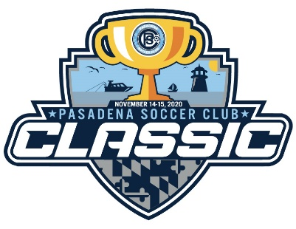

PSC CLASSIC
(fka Mountain Road Tournament)

November 13-15, 2020

The PSC Classic is a Got Soccer Event!!!!!

Format: Two-day tournament, Friday night optional games, three games guaranteed.

Age Groups: Boys and Girls teams (mixed teams accepted for Boys divisions) U-7 through U-18 based on USYSA birth year age groups:

U7 (2014) – U10 (2011) 7v7 12 Max Roster $500
U11 (2010) – U12 (2009) 9v9 16 Max Roster $550
U13 (2008) – U18 (2005/4) 11v11 18 Max Roster $600

Eligibility: The tournament is open only to members of US Youth Soccer and its State Associations. Each team
must be registered with a National State Soccer Association affiliated with USYSA/USSF and must present a valid state or county roster from the Fall 2020 season. Coaches of recreational teams must always have proof of age available in a form that is in accordance with USYSA/USSF Travel and Tournament Policy Manual. Age determination follows FIFA rules. Player credentials will be verified. Tournament Officials have the right to verify eligibility at any time. Any team fielding an ineligible player will be disqualified and that team’s tournament entry fees forfeited.

Teams will not be accepted to tournament until Payment is received in full. No player may play for more than one team in the tournament. Teams that field the same player will forfeit all matches.

Co-ed teams will play in boys’ divisions.

Registration: Teams will be required to present current player passes for all players, certified state rosters, and medical release forms. Permission to travel forms are only required for teams outside of Region 1. Specific information about registration will be included in the team’s acceptance packages. Any team that does not have all of the above documentation at registration on game day will not be allowed to participate and will forfeit their registration fees.

Awards: Individual awards will be given to the 1st and 2nd place finishers in each age group bracket

Application: Registration is through gotsoccer, tournament information can be found at www.pasadenasoccerclub.com/tournaments/psc-classic

After application is submitted the fees and any correspondence should be mailed to;

Pasadena Soccer Club - Tournament
PO Box 800
Pasadena, MD 21123

Information: For any additional information contact; Tournament Director at email tournament@pasadenasoccerclub.com or check us out on our web page www.pasadenasoccerclub.com

